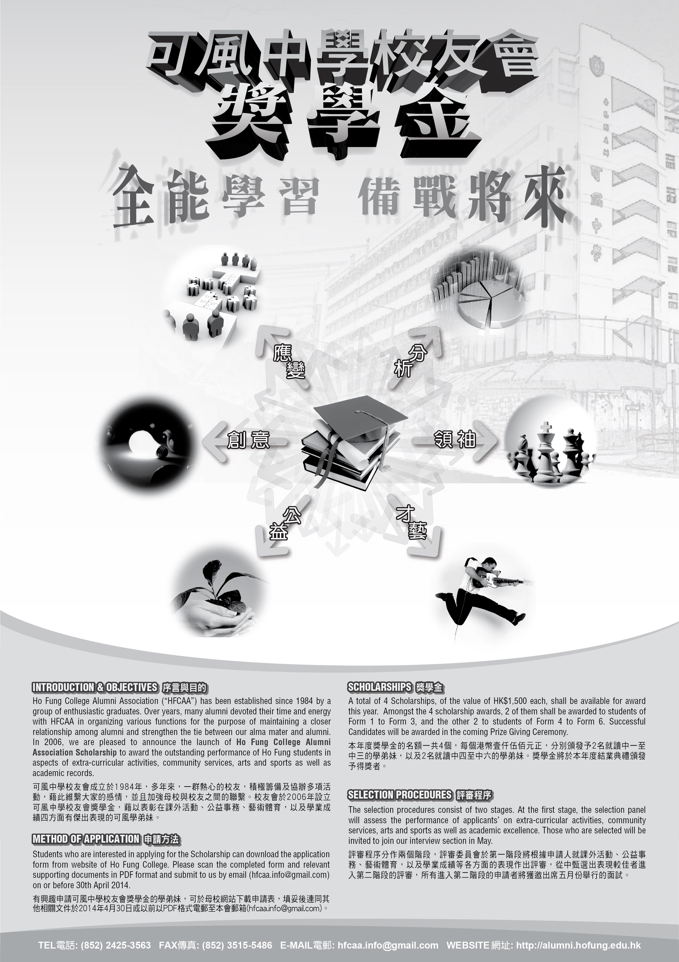

**HO FUNG COLLEGE ALUMNI ASSOCIATION**

**可 風 中 學 校 友 會**

**448 WO YI HOP ROAD, KWAI CHUNG, NEW TERRITORIES**

**新 界 葵 涌 和 宜 合 道 448 號**

**TEL電話: (852) 2425-3563 FAX傳真: (852) 3515-5486 E-MAIL電郵: hfcaa.info@gmail.com WEBSITE網址: http://alumni.hofung.edu.hk**

|  |  |  |  |  |  |  |  |  |  |  |  |  |  |  |  |  |  |  |  |
| --- | --- | --- | --- | --- | --- | --- | --- | --- | --- | --- | --- | --- | --- | --- | --- | --- | --- | --- | --- |
| **APPLICATION FOR SCHOLARSHIP 2014**  **2014年 度 獎 學 金 申 請 表** | | | | | | | | | | | | | | | | | | | |
| * Please scan the completed form and relevant supporting documents in PDF format and submit to us by email ([hfcaa.info@gmail.com](mailto:hfcaa.info@gmail.com)) **on or before 30th April 2014**. Late application will not be accepted.   填妥後連同其他相關文件於**2014年4月30日或以前**以PDF格式電郵至本會郵箱 ([hfcaa.info@gmail.com](mailto:hfcaa.info@gmail.com)), 逾期概不受理。   * You are suggested to seek for help if you encounter any problems in filling this application form.   如在填寫表格時遇有任何疑問，建議向老師或班主任請教。   * This application form can be copied if necessary.   如表格不敷填寫，可自行影印。 | | | | | | | | | | | | | | | | | | PHOTO | |
|  | | | | | | | | | | | | | | | | | | | |
| **Personal Particulars 個人資料** | | | | | | | | | | | | | | | | | | | |
| Name in English: | | | | | | | | | 中文姓名: | | | | | | | Contact 電話: | | |
| Class 班別: | | | | | Sex 性別: | | | | | | | Email 電郵: | | | | | | | |
|  | | | | | | | | | | | | | | | | | | |
| **Extra-curricular Activities (Internal & External) 課外活動 (校內及校外)** | | | | | | | | | | | | | | | | | | |
| Name of Activities  參與活動名稱 | | | | | | Period of Involvement參與年份 | | | | Position Held  擔任職位 | | | Achievement(s) and Contribution(s) in the activities concerned  在活動中所作的貢獻 / 所獲榮譽 | | | | | |
|  | | | | | |  | | | |  | | |  | | | | | |
|  | | | | | | | | | | | | | | | | | | |
| **Community Services (Internal & External) 公益事務 (校內及校外)** | | | | | | | | | | | | | | | | | | |
| Period of Participation  參與年份 | Name of Organization(s)  舉辦機構名稱 | | | | | | | Name of Activities  參與活動名稱 | | | | | Achievement(s) and Contribution(s) in the activities concerned  在活動中所作的貢獻 / 所獲榮譽 | | | | | |
|  |  | | | | | | |  | | | | |  | | | | | |
|  |  | | | | | | |  | | | | |  | | | | | |
| **Your Specialty / Achievement(s) in Arts & Sports 藝術及體育項目上的個人專長 / 成就** | | | | | | | | | | | | | | | | | | |
| Area(s) of Specialty  專長項目 | | | | | | | Award(s) / Achievement(s)  所獲榮譽 / 成就 | | | | | | | | | | | |
|  | | | | | | |  | | | | | | | | | | | |
| **Academic Achievement(s) 學業成就**  *Please state the awards and scholarships obtained during your secondary school education.*  *請填寫就讀中學期間所獲得的學業獎項及獎學金。* | | | | | | | | | | | | | | | | | | |
| Awarded Year獲獎年份 | | Name of Scholarship / Award  獎學金 / 獎項名稱 | | | | | | | | | | | | Awarded Field(s)  獲獎範疇 | | | | |
| . | |  | | | | | | | | | | | |  | | | | |
|  | | | | | | | | | | | | | | | | | | |
| **Briefly describe your personality and characteristics, as well as your future goals and objectives so as to let the Selection Board know more about you.**  **試簡述您的性格及特質，人生目標及抱負，讓獎學金委員會更能認識您。** | | | | | | | | | | | | | | | | | | |
|  | | | | | | | | | | | | | | | | | | |
|  | | | | | | | | | | | | | | | | | | |
| **Declaration 聲明** | | | | | | | | | | | | | | | | | | |
| I hereby apply for the award of the **2014 Ho Fung College Alumni Association Scholarship** and declare that the information provided above is accurate and complete. I understand any misrepresentation will disqualify my application.  本人謹此聲明就申請**2014年度可風中學校友會奬學金**所提供的資料乃正確無誤及完整，本人明白任何失實陳述將會導致本人的申請資格被取消。 | | | | | | | | | | | | | | | | | | |
| **Signature簽署** | | | **:** |  | | | | | | | **Date 日期** | | | | **:** | |  | |
| **Name in English** | | | **:** |  | | | | | | | **Class 班別** | | | | **:** | |  | |